**Table 1. Baseline patient and tumour characteristics by centre.**

|  |  |  |  |  |  |
| --- | --- | --- | --- | --- | --- |
|  | **Total (N=4071)** | **Amsterdam (N=983)** | **Berlin (N=1343)** | **Rotterdam (N=566)** | **Warsaw (N=1179)** |
| **Positive SN status** | 889 (21.8%) | 236 (24.0%) | 259 (19.3%) | 170 (30.0%) | 224 (19.0%) |
| **Males** | 1996 (49.0%) | 497 (50.6%) | 753 (56.1%) | 273 (48.2%) | 473 (40.1%) |
| **Age** |  |  |  |  |  |
| Median (Q1, Q3) | 55.0 (43.0, 66.0) | 55.0 (43.0, 65.0) | 62.0 (48.0, 71.0) | 52.0 (40.0, 62.0) | 51.0 (42.0, 62.0) |
| Min - Max | 13.0 - 94.0 | 15.0 - 89.0 | 13.0 - 94.0 | 13.0 - 88.0 | 15.0 - 83.0 |
| **Ulceration** | 1171 (29.8%) | 265 (27.8%) | 263 (20.0%) | 166 (33.3%) | 477 (40.9%) |
| Missing | 141 | 30 | 31 | 68 | 12 |
| **Location** |  |  |  |  |  |
| Arm | 615 (15.6%) | 128 (13.5%) | 217 (16.2%) | 86 (15.2%) | 184 (17.0%) |
| Leg | 1189 (30.2%) | 277 (29.2%) | 324 (24.2%) | 218 (38.5%) | 370 (34.3%) |
| Trunk | 1815 (46.1%) | 407 (42.8%) | 654 (48.9%) | 242 (42.8%) | 512 (47.4%) |
| Head and neck | 314 (8.0%) | 138 (14.5%) | 142 (10.6%) | 20 (3.5%) | 14 (1.3%) |
| Missing | 138 | 33 | 6 | 0 | 99 |
| **Histology** |  |  |  |  |  |
| SSM | 2164 (58.2%) | 598 (62.6%) | 910 (70.0%) | 285 (55.9%) | 371 (39.0%) |
| NM | 1226 (33.0%) | 276 (28.9%) | 290 (22.3%) | 195 (38.2%) | 465 (48.8%) |
| ALM | 126 (3.4%) | 29 (3.0%) | 54 (4.2%) | 16 (3.1%) | 27 (2.8%) |
| LMM | 153 (4.1%) | 18 (1.9%) | 45 (3.5%) | 5 (1.0%) | 85 (8.9%) |
| Other | 49 (1.3%) | 35 (3.7%) | 1 (0.1%) | 9 (1.8%) | 4 (0.4%) |
| Missing | 353 | 27 | 43 | 56 | 227 |
| **Breslow** |  |  |  |  |  |
| Mean (SD) | 2.8 (3.3) | 2.6 (2.0) | 2.3 (2.5) | 2.8 (2.3) | 3.6 (4.9) |
| Min - Max | 0.1 - 90.0 | 0.5 - 22.0 | 0.1 - 30.0 | 0.3 - 20.0 | 0.1 - 90.0 |
| Missing | 59 | 9 | 16 | 6 | 28 |
| **Multiple fields** | 374 (9.2%) | 223 (22.7%) | 41 (3.1%) | 87 (15.4%) | 23 (2.0%) |
| **Total number of negative SN** |  |  |  |  |  |
| Mean (SD) | 1.7 (1.4) | 2.2 (1.6) | 1.6 (1.3) | 1.6 (1.4) | 1.2 (1.0) |
| Min - Max | 0.0 - 15.0 | 0.0 - 15.0 | 0.0 - 13.0 | 0.0 - 10.0 | 0.0 - 9.0 |
| Missing | 162 | 0 | 27 | 1 | 134 |
| **Total number of positive SN** |  |  |  |  |  |
| Mean (SD) | 0.3 (0.6) | 0.3 (0.6) | 0.2 (0.4) | 0.4 (0.7) | 0.3 (0.6) |
| Min - Max | 0.0 - 5.0 | 0.0 - 4.0 | 0.0 - 2.0 | 0.0 - 4.0 | 0.0 - 5.0 |
| Missing | 1 | 0 | 1 | 0 | 0 |
| **SN tumour burden** |  |  |  |  |  |
| Mean (SD) | 1.2 (1.3) | 1.1 (0.8) | 1.0 (0.5) | 1.1 (1.3) | 1.4 (2.0) |
| Min - Max | 0.0 - 38.0 | 0.0 - 8.0 | 0.0 - 8.0 | 0.0 - 15.0 | 0.0 - 38.0 |
| Missing | 301 | 120 | 163 | 18 | 0 |
| **Location metastasis in lymph** |  |  |  |  |  |
| Subcap | 3319 (88.1%) | 793 (92.1%) | 1123 (95.2%) | 440 (80.3%) | 963 (81.7%) |
| Combined | 213 (5.7%) | 39 (4.5%) | 27 (2.3%) | 43 (7.8%) | 104 (8.8%) |
| Parenchymal | 86 (2.3%) | 5 (0.6%) | 11 (0.9%) | 19 (3.5%) | 51 (4.3%) |
| Multifocal | 45 (1.2%) | 6 (0.7%) | 9 (0.8%) | 21 (3.8%) | 9 (0.8%) |
| Extensive | 105 (2.8%) | 18 (2.1%) | 10 (0.8%) | 25 (4.6%) | 52 (4.4%) |
| Missing | 303 | 122 | 163 | 18 | 0 |
| **Recurrence** | 862 (21.2%) | 208 (21.2%) | 175 (13.0%) | 160 (28.3%) | 319 (27.1%) |
| **Deaths** | 606 (14.9%) | 127 (12.9%) | 148 (11.0%) | 115 (20.3%) | 216 (18.3%) |
| **Melanoma specific mortality** | 504 (12.4%) | 98 (10.0%) | 101 (7.5%) | 102 (18.0%) | 203 (17.2%) |

Abbreviations: Q1, first quantile (Q1); Q3, third quantile; SD, standard deviation; SN, sentinel node, SSM, superficial spreading melanoma; NM, nodular melanoma; ALM, acral lentiginous melanoma; LMM, lentigo maligna melanoma.

**Table 2. Hazard ratios of full model predicting 5-year recurrence**. This Table displays the hazard ratios together with the 95 percent confidence intervals of the full Cox proportional hazards model predicting 5-year recurrence.

|  |  |  |  |
| --- | --- | --- | --- |
|  | **Full model** | | |
|  | **HR** | **CI** | $$χ^{2}$$ |
| **Positive SN status** | 1.196 | [0.165; 8.649] | 35.2 |
| **Male** | 1.229 | [1.016; 1.487] | 4.6 |
| Positive SN status * Male | 0.798 | [0.597; 1.065] | 2.4 |
| **Age** | 1.151 | [0.849; 1.561] | 7.7 |
| Positive SN status * Age | 1.398 | [0.878; 2.227] | 2.0 |
| **Ulceration** | 1.752 | [1.438; 2.136] | 38.0 |
| Positive SN status * Ulceration | 0.779 | [0.575; 1.054] | 2.6 |
| **Location** |  |  |  |
| Arm | (ref) |  | 22.2 |
| Leg | 1.394 | [1.034; 1.879] |  |
| Trunk | 1.515 | [1.132; 2.027] |  |
| Head and neck | 2.319 | [1.593; 3.375] |  |
| Positive SN status * Arm | (ref) |  | 1.2 |
| Positive SN status * Leg | 0.828 | [0.444; 1.543] |  |
| Positive SN status * Trunk | 0.789 | [0.436; 1.425] |  |
| Positive SN status * Head and neck | 0.68 | [0.334; 1.385] |  |
| **Histology** |  |  |  |
| SSM | (ref) |  | 12.8 |
| NM | 1.243 | [0.973; 1.587] |  |
| ALM | 1.667 | [1.015; 2.738] |  |
| LMM | 1.089 | [0.642; 1.848] |  |
| Other | 0.864 | [0.395; 1.891] |  |
| Positive SN status * SSM | (ref) |  | 0.4 |
| Positive SN status * NM | 1.04 | [0.736; 1.468] |  |
| Positive SN status * ALM | 0.871 | [0.422; 1.799] |  |
| Positive SN status * LMM | 0.979 | [0.344; 2.787] |  |
| Positive SN status * other | 0.689 | [0.083; 5.712] |  |
| **Breslow** | 2.132 | [1.847; 2.461] | 128.6 |
| Positive SN status * Breslow | 0.716 | [0.575; 0.891] | 8.9 |
| **Multiple fields** | 1.314 | [0.957; 1.803] | 6.1 |
| Positive SN status * Multiple fields | 1.027 | [0.664; 1.590] | 0.0 |
| **Total number of negative SN** | 0.973 | [0.919; 1.029] | 0.9 |
| **Total number of positive SN** | 0.971 | [0.817; 1.153] | 0.1 |
| **SN tumour burden (Rdamcrit)** | 1.197 | [1.035; 1.385] | 5.9 |
| **Location metastasis in lymph node (Dewar)** |  |  |  |
| Subcap | (ref) |  | 6.1 |
| Combined | 1.446 | [0.998; 2.096] |  |
| Parenchymal | 1.111 | [0.693; 1.784] |  |
| Multifocal | 1.009 | [0.609; 1.673] |  |
| Extensive | 1.194 | [0.665; 2.145] |  |
| *Intercept* | -1.414 | [-1.488; -1.340] |  |
| *Slope* | 0.999 | [0.926; 1.073] |  |
| *C-index* | 0.766 | [0.750; 0.781] |  |
| *C-index recalibrated MSS* | 0.791 | [0.771; 0.811] |  |

C-index is corrected for optimism. Abbreviations: HR, hazard ratio; CI, 95 percent confidence interval; $χ^{2}$, chi-square form anova test; SN, sentinel node, SSM, superficial spreading melanoma; NM, nodular melanoma; ALM, acral lentiginous melanoma; LMM, lentigo maligna melanoma.

**Table 3. Hazard ratios of final model predicting 5-year recurrence**. This Table displays the hazard ratios together with the 95 percent confidence intervals of the full Cox proportional hazards model predicting 5-year recurrence selected by backward selection with p-values maximum of 0.01.

|  |  |  |  |
| --- | --- | --- | --- |
|  | **Full model** | | |
|  | **HR** | **CI** | $$χ^{2}$$ |
| **Positive SN status** | 3.664 | [2.776; 4.837] | 132.8 |
| **Age** | 1.411 | [1.123; 1.773] | 8.7 |
| **Ulceration** | 1.639 | [1.415; 1.899] | 43.3 |
| **Location** |  |  |  |
| Arm | (ref) | (ref) | 21.8 |
| Leg | 1.311 | [1.015; 1.693] |  |
| Trunk | 1.479 | [1.159; 1.889] |  |
| Head and neck | 2.007 | [1.476; 2.729] |  |
| **Breslow** | 2.261 | [2.011; 2.542] | 205.7 |
| Positive SN status * Breslow | 0.673 | [0.557; 0.814] | 16.7 |
| **SN tumour burden (Rdamcrit)** | 1.238 | [1.132; 1.353] | 22.1 |
| *Intercept* | -1.390 | [-1.463; -1.316] |  |
| *Slope* | 1.000 | [0.925; 1.074] |  |
| *C-index* | 0.762 | [0.746; 0.777] |  |
| *C-index recalibrated MSS* | 0.788 | [0.768; 0.808] |  |

C-index is corrected for optimism. Abbreviations: HR, hazard ratio; CI, 95 percent confidence interval; $χ^{2}$, chi-square form anova test; SN, sentinel node, SSM, superficial spreading melanoma; NM, nodular melanoma; ALM, acral lentiginous melanoma; LMM, lentigo maligna melanoma.

**Figure 1. Risk distribution and nomogram**.

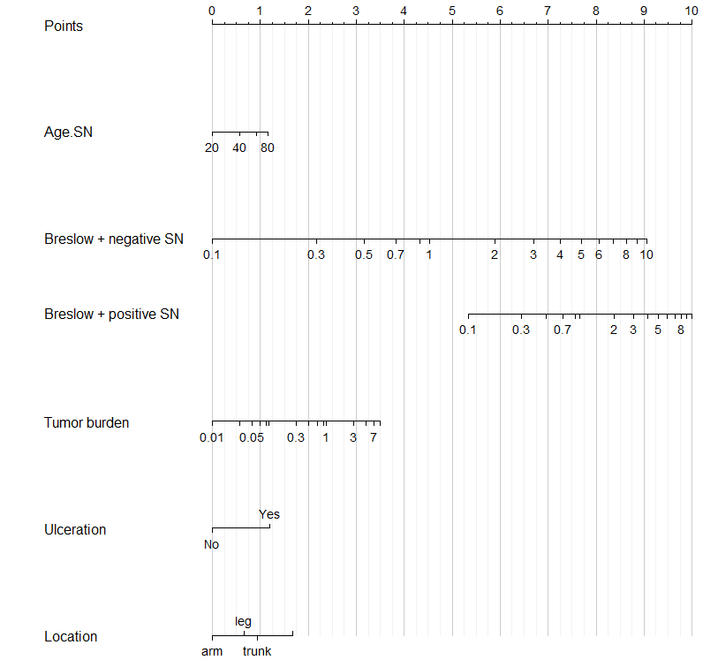

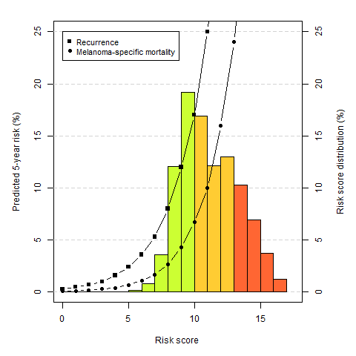

**Figure 1. Calibration curves for final model predicting recurrence and melanoma specific mortality for each centre for patients with positive or negative sentinel nodes.**

|  |  |  |
| --- | --- | --- |
|  | **Recurrence** | **Melanoma specific mortality** |
| **Both positive and negative** |  |  |
| **Only positive** |  |  |
| **Only negative** |  |  |

**SUPPLEMENT**

**Table 2. Hazard ratios of refitted full model predicting 5-year melanoma specific mortality**. This Table displays the hazard ratios together with the 95 percent confidence intervals of the refitted full Cox proportional hazards model predicting 5-year melanoma specific mortality.

|  |  |  |  |
| --- | --- | --- | --- |
|  | **Full model** | | |
|  | **HR** | **CI** | $$χ^{2}$$ |
| **Positive SN status** | 0.385 | [0.030; 4.936] | 35.9 |
| **Male** | 1.408 | [1.093; 1.813] | 8.0 |
| Positive SN status * Male | 0.818 | [0.560; 1.195] | 1.1 |
| **Age** | 0.849 | [0.570; 1.265] | 5.9 |
| Positive SN status * Age | 2.029 | [1.101; 3.740] | 5.1 |
| **Ulceration** | 2.023 | [1.560; 2.624] | 37.2 |
| Positive SN status * Ulceration | 0.774 | [0.524; 1.143] | 1.7 |
| **Location** |  |  |  |
| Arm | (ref) |  | 17.5 |
| Leg | 1.020 | [0.683; 1.525] |  |
| Trunk | 1.683 | [1.162; 2.438] |  |
| Head and neck | 1.761 | [1.029; 3.014] |  |
| Positive SN status * Arm | (ref) |  | 3.6 |
| Positive SN status * Leg | 0.890 | [0.419; 1.891] |  |
| Positive SN status * Trunk | 0.611 | [0.307; 1.219] |  |
| Positive SN status * Head and neck | 0.854 | [0.352; 2.072] |  |
| **Histology** |  |  |  |
| SSM | (ref) |  | 6.3 |
| NM | 1.159 | [0.852; 1.579] |  |
| ALM | 1.684 | [0.845; 3.355] |  |
| LMM | 1.032 | [0.503; 2.120] |  |
| Other | 0.856 | [0.322; 2.280] |  |
| Positive SN status * SSM | (ref) |  | 0.7 |
| Positive SN status * NM | 0.896 | [0.582; 1.378] |  |
| Positive SN status * ALM | 1.029 | [0.389; 2.725] |  |
| Positive SN status * LMM | 0.695 | [0.137; 3.530] |  |
| Positive SN status * other | 0.013 | [0.000; 140697.262] |  |
| **Breslow** | 2.300 | [1.898; 2.786] | 92.6 |
| Positive SN status * Breslow | 0.690 | [0.515; 0.925] | 6.2 |
| **Multiple fields** | 1.054 | [0.686; 1.621] | 1.9 |
| Positive SN status * Multiple fields | 1.267 | [0.708; 2.271] | 0.6 |
| **Total number of negative SN** | 0.967 | [0.894; 1.045] | 0.7 |
| **Total number of positive SN** | 0.925 | [0.739; 1.158] | 0.5 |
| **SN tumour burden (Rdamcrit)** | 1.285 | [1.089; 1.517] | 8.8 |
| **Location metastasis in lymph node (Dewar)** |  |  |  |
| Subcap | (ref) |  | 2.7 |
| Combined | 1.187 | [0.739; 1.906] |  |
| Parenchymal | 1.523 | [0.897; 2.588] |  |
| Multifocal | 1.344 | [0.700; 2.579] |  |
| Extensive | 1.290 | [0.667; 2.498] |  |
| *Intercept* | -1.260 | [-1.700; -0.820] |  |
| *Slope* | 0.999 | [0.911; 1.087] |  |
| *C-index* | 0.797 | [0.777; 0.816] |  |

C-index corrected for optimism. Abbreviations: HR, hazard ratio; CI, 95 percent confidence interval; $χ^{2}$, chi-square form anova test; SN, sentinel node, SSM, superficial spreading melanoma; NM, nodular melanoma; ALM, acral lentiginous melanoma; LMM, lentigo maligna melanoma.

**Table 3. Hazard ratios of refitted final model predicting 5-year melanoma specific mortality**. This Table displays the hazard ratios together with the 95 percent confidence intervals of the refitted full Cox proportional hazards model predicting 5-year recurrence selected by backward selection with p-values maximum of 0.01.

|  |  |  |  |
| --- | --- | --- | --- |
|  | **Full model** | | |
|  | **HR** | **CI** | $$χ^{2}$$ |
| **Positive SN status** | 4.202 | [2.893; 6.103] | 98.3 |
| **Male** | 1.418 | [1.188; 1.692] | 10.9 |
| **Ulceration** | 1.789 | [1.477; 2.165] | 35.6 |
| **Breslow** | 2.374 | [2.035; 2.769] | 10.9 |
| Positive SN status * Breslow | 0.657 | [0.512; 0.843] | 494.9 |
| **SN tumour burden (Rdamcrit)** | 1.335 | [1.195; 1.491] | 10.9 |
| *Intercept* | -1.199 | [-1.664; -0.733] |  |
| *Slope* | 1.000 | [0.912; 1.088] |  |
| *C-index* | 0.788 | [0.768; 0.808] |  |

C-index corrected for optimism. Abbreviations: HR, hazard ratio; CI, 95 percent confidence interval; $χ^{2}$, chi-square form anova test; SN, sentinel node, SSM, superficial spreading melanoma; NM, nodular melanoma; ALM, acral lentiginous melanoma; LMM, lentigo maligna melanoma.